**Maratona Explorer 3.0 - Aula 03: Como acelerar sua evolução**

<https://www.youtube.com/watch?v=j7vcELuKne0&t=33s>

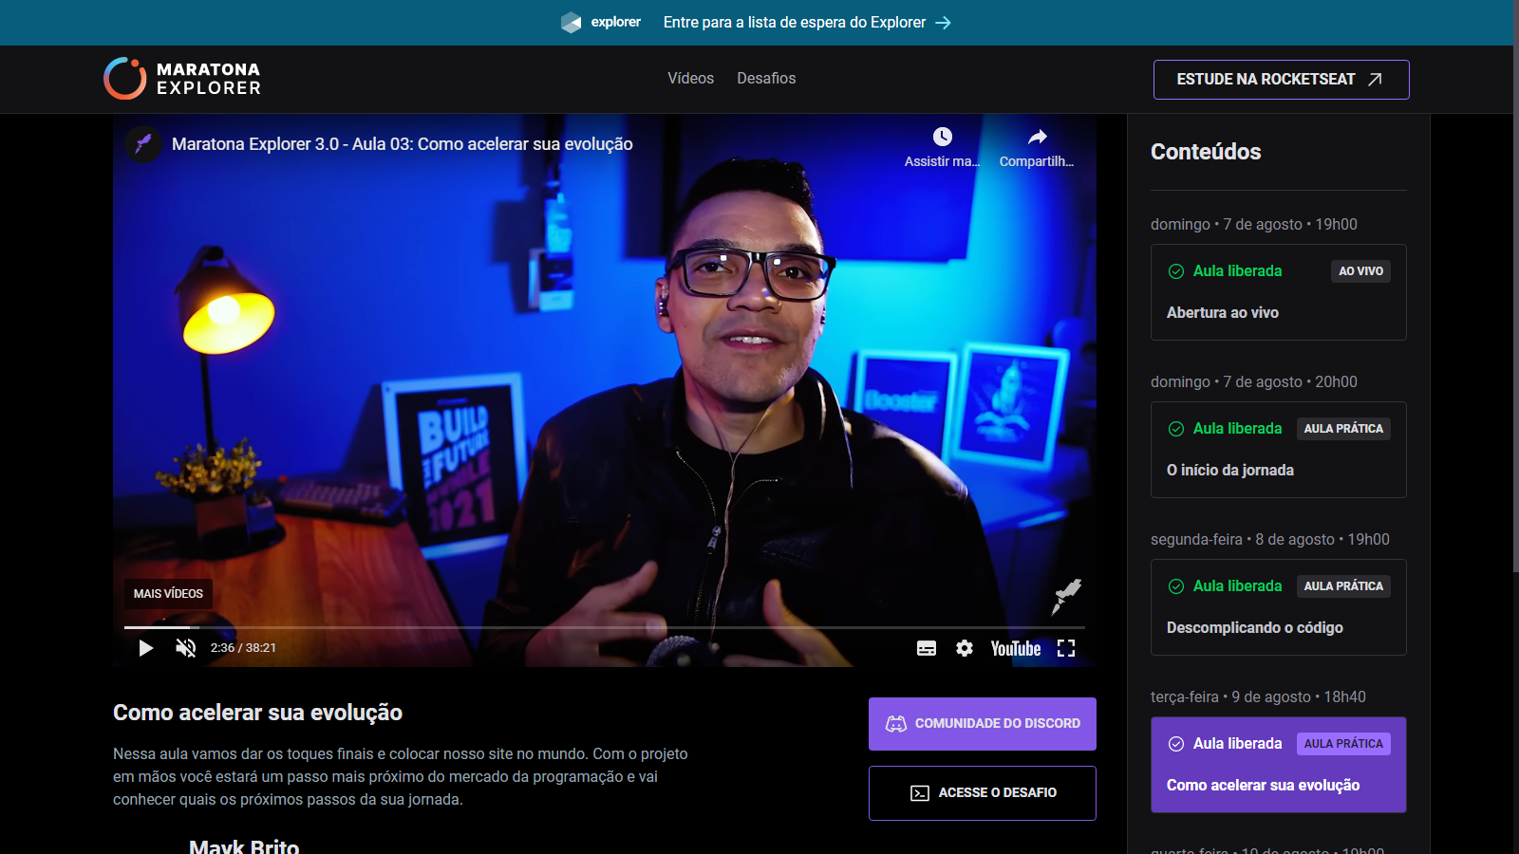

<https://evento.rocketseat.com.br/maratona/explorer/aula-3>

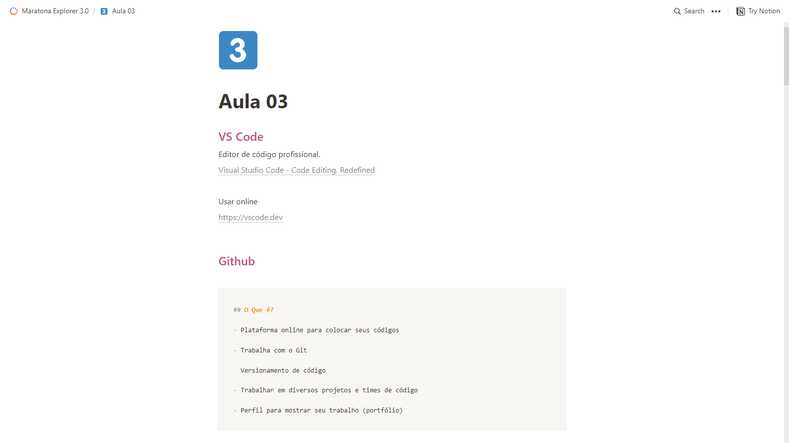<https://efficient-sloth-d85.notion.site/Aula-03-33dd21cd310b4a86b9f278e4021b4bf8>

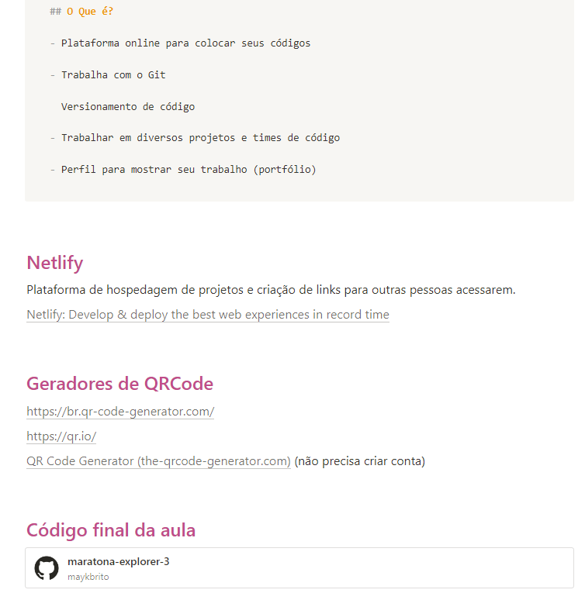LINKS E SITES ACESSADOS NESTA AULA:

CONSTRUIR O LAYOUT / DESIGN DO SITE:

<https://www.figma.com/file/ccU2XYmSzNKpDjrHb51Q7T/Untitled>

GOOGLE FONTES

<https://fonts.google.com/>

FONTE: PLAYFAIR DISPLAY

<https://fonts.google.com/betterspecimen/Playfair+Display>

FONTE: ROBOTO SERIF

<https://fonts.google.com/betterspecimen/Roboto+Serif?query=roboto+serif+&preview.size=66>

NETLIFY – CRIADOR DE SITES NA INTERNET

<https://app.netlify.com/teams/danilex22/overview>

LINK FINAL DO SITE

<https://app.netlify.com/sites/funny-tapioca-b0ffcf>

CASO QUEIRA PROFISSIONALIZAR UM DOMÍNIO

<https://registro.br/>

SITE ONDE EU CONSTRUI O QR CODE

<https://qr.io/dashboard/>

ENCURTADOR DE URL

<https://bitly.com/>

URL ENCURTADA

<https://bit.ly/3SHAK1a>



